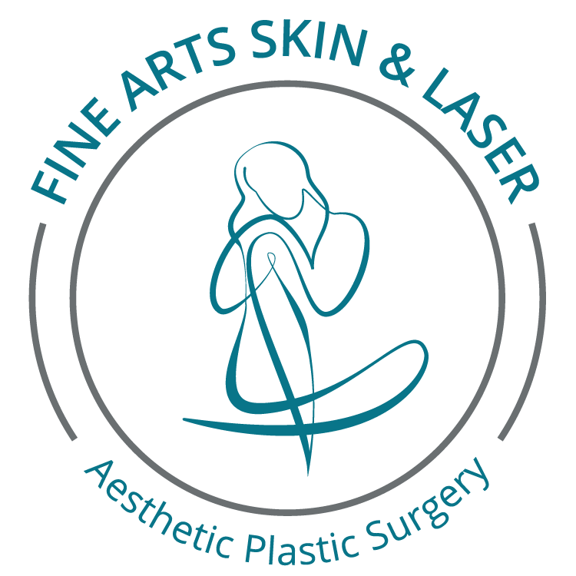

**Authorization for Use or Disclosure of Client Photographic   
and/or Video Images**

Please read each section below and initial on the line.

**Authorization:**

_____ I authorize the use and disclosure of my (check all applicable boxes below):

🞏 Name

🞏 Photographic/video images

🞏 Testimonial

for marketing purposes by Fine Arts Skin & Laser. I understand that information disclosed pursuant to this authorization may be subject to redisclosure and may no longer by protected by HIPAA privacy regulations.

**Purpose**

_____ The photographic/video images, and/or testimonial may be used on our website, print and social media and/or for advertising purposes.

**Revocability**

_____ I understand that I may revoke this authorization at any time, but such revocation must be in writing and delivered to Fine Arts Skin & Laser.

_____ I understand that I have the right to inspect or copy the information to be used or disclosed pursuant to this consent.

**No Treatment Conditions**

_____ Refusal to consent to the use of this information will in no way affect the medical care I receive, my payment options, or eligibility for benefits. I understand that Fine Arts Skin & Laser cannot condition treatment on whether or not I sign this authorization.

I have read the above and understand it. All of my questions have been answered satisfactorily. I allow Fine Arts Skin & Laser to use my information as indicated above for promotional purposes. This consent will expire one (1) year from the date listed below, beside my name. If I wish to withdraw this consent before that time, I may do so with a written request. I understand that I may revoke this authorization except to the extent that action has already been taken in reliance on this authorization.

______________________________________________ _______________________________________

Patient Name (printed) and signature Date

To be completed by Fine Arts Skin & Laser:

Will Fine Arts Skin & Laser receive financial or in-kind compensation in exchange for using or disclosing the health information described above?

* Yes
* No

____________________________________________ __________________________________

Employee Print Name / Date Signature

4846-4449-8385, v. 2