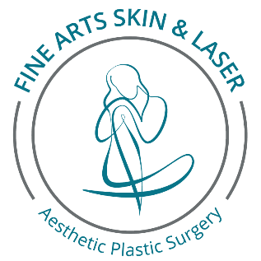

**Aesthetic Goals Questionnaire**

Client Name ______________________________________________________________Date_____________________

Address ___________________________________________________________________________________________

City ______________________________________State_______________Zip Code _____________________________

Preferred Contact Number ___________________ Preferred Email Address ________________________________

Please let us know the primary concern that brought you into our office today: _________________________________

__________________________________________________________________________________________________

**Please answer the following questions using the scales provided as honestly as possible.**

*How concerning is the appearance of your wrinkles as you look in the mirror?*

Not Concerning Somewhat Concerning Very Concerning

1 -------------------- 2 -------------------- 3 -------------------- 4 ---------------------- 5 --------------------- 6 --------------------- 7

*I believe that I look younger, the same as, or older than my age.*

Younger Than True Age Older Than

1 -------------------- 2 -------------------- 3 -------------------- 4 ---------------------- 5 --------------------- 6 --------------------- 7

**What are your preferred methods of contact (mark all that apply)?**

O Cell O Home Phone O Text Message O Email

**How did you hear about us?**

* **A friend or family member (Name)? _________________________________________________**
* **Internet? Website Name? _________________________________________________________**
* **Event? Which one? _______________________________________________________________**
* **Magazine, Radio or Newspaper? Name? ______________________________________________**
* **Facebook/Instagram/Social Media**
* **ENT Patient**

What treatments or concerns are you interested in learning more about during your visit today? Use the extra space to elaborate if you wish.

|  |  |  |  |
| --- | --- | --- | --- |
|  | BOTOX/Dysport |  | Eye Lid Rejuvenation/Lift |
|  | Dermal Fillers |  | Brow/Forehead Lift |
|  | Laser Hair Removal |  | Facelift |
|  | Age Spots |  | Double Chin Treatments |
|  | Sun Damage |  | SculpSure Body Contouring |
|  | Facial Redness |  | SmartLipo Laser Liposuction |
|  | Medical Grade Skin Care |  | Nose Reshaping |
|  | Looking Tired |  | Latisse Eyelash Enhancement |
|  | Fine Lines/Wrinkles |  | Excessive Underarm Sweating |
|  | Broken Capillaries |  | Spider veins |
|  | Acne or Scarring |  | Radiofrequency Micro-Needling Skin Rejuvenation |
|  | Fat Transfers |  | Oily skin |
|  | Lines around the eyes or forehead |  | Wrinkled Neck/Neck Lift |
|  | Thin Lips |  | Unwanted Body Fat |
|  | Dry Skin |  | Dull Skin Appearance |
|  | Red and Brown Spots |  | Lines Around the Mouth |
|  | Micro-Dermabrasion |  | Other: |

**________________________________________________ _______________________________________**

**Patient Signature Printed Name**

**_________________________**

**Date**